Lesson Plan  
Virtual Machine Installation

short line

# Summary

1. Introduction
2. Caution
3. Install: VMware, VirtualBox, Vmware Fusion ( MAC users )
4. Install Images
5. AWS Setup

# Introduction

## Virtual Machine

* + A **virtual machine** is a computer file, typically called an image, that behaves like an actual computer. In other words, creating a computer within a computer. It runs in a window, much like any other program, giving the end user the same experience on a virtual machine as they would have on the host operating system itself. The virtual machine is sandboxed from the rest of the system, meaning that the software inside a virtual machine can’t escape or tamper with the computer itself. This produces an ideal environment for testing other operating systems including beta releases, accessing virus-infected data, creating operating system backups, and running software or applications on operating systems they weren’t originally intended for.
* Objective
  + We will create Virtual Machines in our computers, and create our own testing environment that has CLEAN network meaning there are no other computer traffic in this test environment.

# Caution

* If you are in one of these categories, you should consider running your Virtual Machines in Cloud.
  + You have Less than 4 GB of RAM
    - If you have 4 GB of RAM, your Virtual Machines will eat up all that memory, and will run really slowly.
  + You have less than 100 GB of Hard Disk Space
    - Some virtual machines can go up to 80 GB memory. It is a good idea to save these machines in external hard-drive.
    - However, running the VMs from external hard-drive can significantly lower the speed of VMs

# Install

## Windows Users

* If you have a windows computer, you are free to pick VirtualBox or VMware
* VMware Workstation Pro - Not Free
  + <https://e5.onthehub.com/WebStore/Support/RequestCustomerSupport.aspx?src=RequestAnAccount&ws=a4fce2bc-ac2d-de11-a497-0030485a8df0&vsro=8>
* Vmware Workstation Player - Free
  + <https://www.vmware.com/products/workstation-player/workstation-player-evaluation.html>
* VirtualBox - Free
  + <https://www.virtualbox.org/wiki/Downloads>

Linux / Unix Users

* You are also free to pick either VirtualBox or VMware
* VMware Workstation Pro - Not Free
  + <https://e5.onthehub.com/WebStore/Support/RequestCustomerSupport.aspx?src=RequestAnAccount&ws=a4fce2bc-ac2d-de11-a497-0030485a8df0&vsro=8>
* Vmware Workstation Player - Free
  + <https://www.vmware.com/products/workstation-player/workstation-player-evaluation.html>
* Otherwise, if you don’t like to do that, VirtualBox has everything you need for free.
  + <https://www.virtualbox.org/wiki/Downloads>

MAC / OSX Users

* You do not have freedom to pick either one of those above.
* Your options are
  + Vmware Fusion
    - Not free, but you can get it for free if you ask CS department
    - <https://e5.onthehub.com/WebStore/Support/RequestCustomerSupport.aspx?src=RequestAnAccount&ws=a4fce2bc-ac2d-de11-a497-0030485a8df0&vsro=8>
  + Parallel
    - <https://www.parallels.com/>
    - Not free again

# Download Images

* It is important to note that you download only from trusted sites!!!
* If you download from a random site, it could possibly have virus installed in those images and destroy your computer.
* Common Images
  + Kali Linux
    - This is a Linux Distribution that has pre-installed most of attacking tools. Thus this is the image to use if you are a Penetration Tester.
    - <https://www.offensive-security.com/kali-linux-vm-vmware-virtualbox-hyperv-image-download/>
  + Ubuntu
    - Another Linux Distribution that is very popular for desktop and servers.
    - <https://www.ubuntu.com/download>
  + Windows
    - Windows images are all licensed and in order to use them, you need to buy expensive licenses. However, Windows released images only for Virtual Machines for developers to use instead of buying everything.
    - <https://developer.microsoft.com/en-us/microsoft-edge/tools/vms/>

# Run

* Once you have all images installed, you can simply double click them or import it from your software.
* VirtualBox
  + File menu -> **Import Appliance**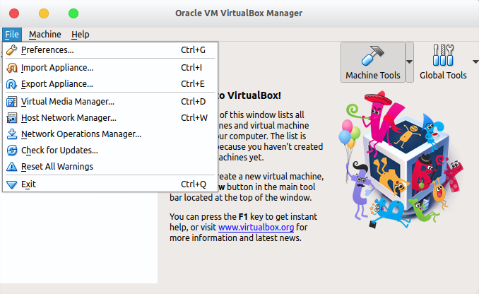
  + 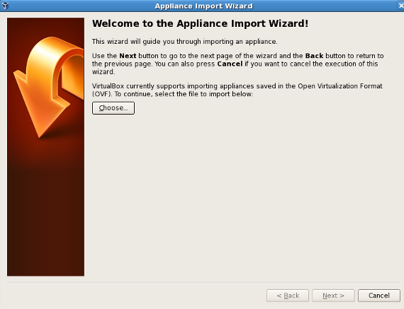
  + Click **Choose** and select your image
  + 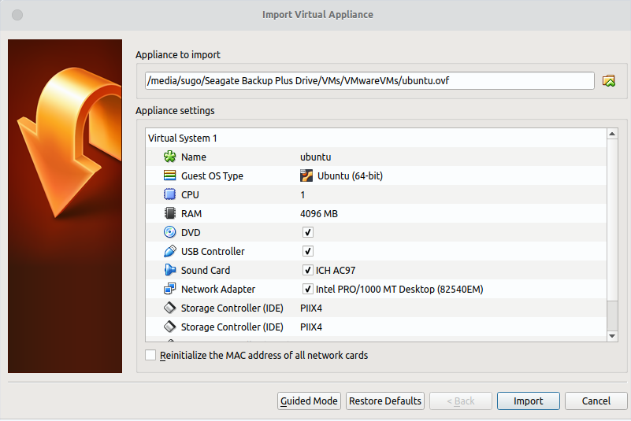
  + Once you’ve selected your image, click **Import**
  + <https://docs.oracle.com/cd/E26217_01/E26796/html/qs-import-vm.html>
* Vmware (Player, Workstation, Fusion)
  + For VMware, you just need to **file -> open** and select your image
  + 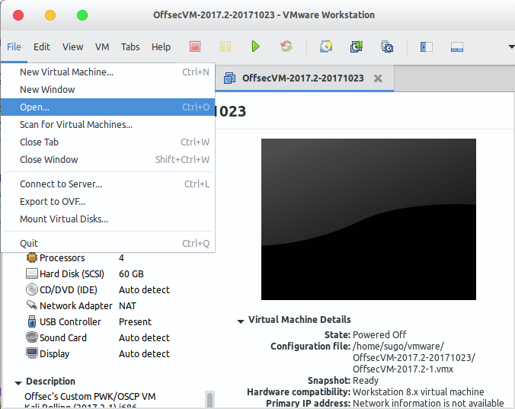
* Settings
  + FAQ
    - FAQ - How much memory should I give to a Virtual Machine?
      * Normally you can get away with 1 ~ 2 GB memory
      * Sometimes if you give too low memory for the machine, it will freeze. If that happens try giving more memory.
    - FAQ - What about CPU?
      * This is completely up to you. You can try 1 processor, and it the machine seems to be running too slow, you can increase it
  + Network Setting
    - Bridged Networking
      * Bridged networking connects a virtual machine to a network by using the network adapter on the host system. If the host system is on a network, bridged networking is often the easiest way to give the virtual machine access to that network.
      * When you install Workstation on a Windows or Linux host system, a bridged network (VMnet0) is set up for you.
    - NAT Networking
      * With NAT, a virtual machine does not have its own IP address on the external network. Instead, a separate private network is set up on the host system. In the default configuration, a virtual machine gets an address on this private network from the virtual DHCP server. The virtual machine and the host system share a single network identity that is not visible on the external network.
      * When you install Workstation on a Windows or Linux host system, a NAT network (VMnet8) is set up for you. When you use the New Virtual Machine wizard to create a new virtual machine and select the typical configuration type, the wizard configures the virtual machine to use the default NAT network.
      * You can have only one NAT network.
    - Host-Only Networking
      * Host-only networking creates a network that is completely contained within the host computer. Host-only networking provides a network connection between the virtual machine and the host system by using a virtual network adapter that is visible on the host operating system.
      * When you install Workstation on a Windows or Linux host system, a host-only network (VMnet1) is set up for you.
      * This means that only your host can connect to your Virtual Machines, and Virtual machines are in its own clean network environment.
    - <https://pubs.vmware.com/workstation-9/index.jsp?topic=%2Fcom.vmware.ws.using.doc%2FGUID-D9B0A52D-38A2-45D7-A9EB-987ACE77F93C.html>
  + Once done with settings, have fun with them.

# AWS Setup

* Although Free Tier Service is available, I recommend everyone to get AWS Educate
  + <https://aws.amazon.com/education/awseducate/>
* Instances
  + In AWS, you call each VM an EC2 instance
  + Also, images are called AMI (Amazon Machine Image)
  + Thus, if you have your custom Virtual machine image, you need to upload it to your account in order to use it in AWS
    - <https://aws.amazon.com/ec2/vm-import/>
* VPC - (Virtual Private Cloud)
  + <https://aws.amazon.com/vpc/>
  + If you only launch instances as EC2 without VPC, you are not putting these machines in a private network, but in a public network.
  + In order to establish a private network environment, you would want to create a VPC, and run EC2 instances inside VPC.
  + Compared to VMware or VirtualBox settings,
    - Host-Only network = VPC
    - Bridged Network = EC2 instances on its own.
* There are millions of resources available on how to set up an AWS instance.
  + <https://aws.amazon.com/getting-started/>

# Final Tip

If you don’t know or not sure about how to do something.

Google first.

**Independent learning** is crucial for your own development.